Grants and Projects

Security Changes
Access to Grants & Project may need to be added in Security. New role(s) maybe created, or access can be added to existing role(s).

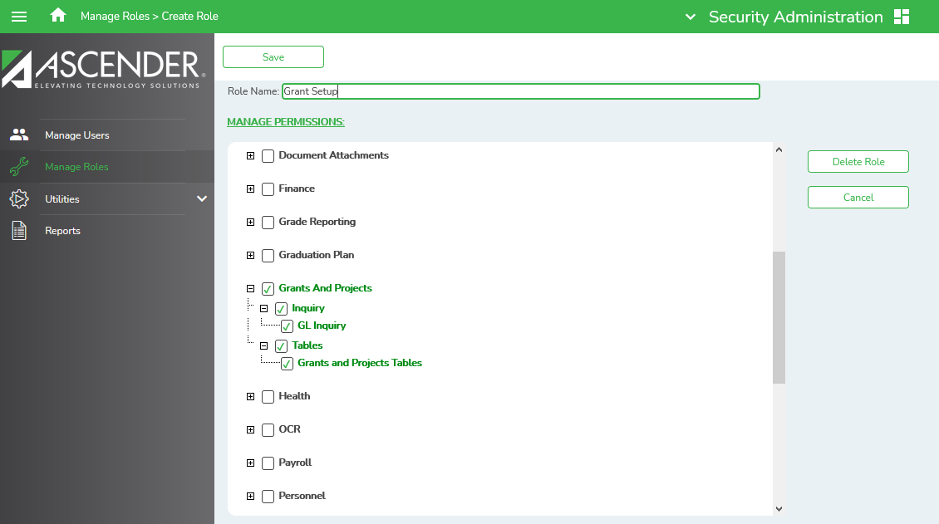

- District Administration > Maintenance > User Profiles > Grants and Projects is used to assign specific grant codes to individual users. This should be added to the role that grants access through District Administration.
- Grants and Projects > Tables > Grants and Projects Tables is used to define grant codes that can be tracked in the Grants and Projects application. This access should be added to roles that will establish grants and projects.
- Grants and Projects > Inquiry > GL Inquiry is used to perform the inquiries for specific grant/project codes. This should be added to roles that will inquire and run reports for grant reporting and administration.

Grant Set-Up

The Grants and Projects table is used to define grant codes that can be tracked in the Grants and Projects application. Each grant code is assigned fund/fiscal years and File IDs to include, allowing information to be combined across File IDs for a complete inquiry or report.

Grants and Projects > Tables > Grants and Projects Table

Click the Add button to add a new grants/project code, assign applicable information and save changes.
- Grant/Project Code – Type up to ten alphanumeric characters to define grant/project code. This is a user-defined code.
- NOGA / Project Nbr –Notice of Grant Award (NOGA) number. This field is optional.
- CFDA Nbr –Catalog of Federal Domestic Assistance (CFDA) number that was assigned to the grant when awarded by the Federal Government. This field is optional.
- Begin Dates– Type the beginning date of the grant. Or, select a date from the calendar. This field is optional.
- End Dates – Type the ending date of the grant. Or, select a date from the calendar. This field is optional.
- Description – Type a description for the code. We recommend adding a date or year to differentiate easily such as Title 1A 2021.
- Grant/Project info. Often grants cross fiscal years/File IDs. Enter as many lines as needed to ensure complete data is retrieved in the application. Consider File IDs, Funds and Fiscal Years. Add additional fields as needed.

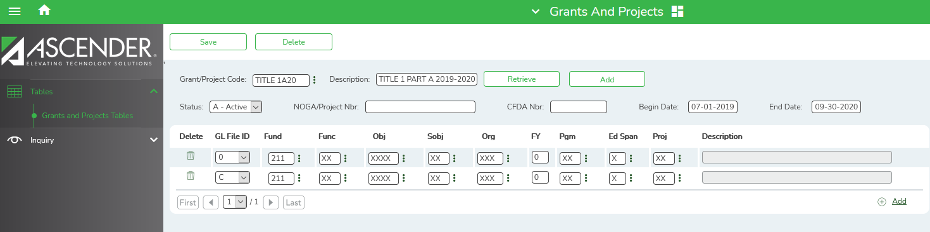

User Profile
Grant/project codes must be assigned to individual users in District Administration to allow a user to view the details associated with the grant code in the Grants and Projects application.

District Administration > Maintenance > User Profiles > Grants and Projects tab.

Retrieve desired user to assign a grant code. Save all changes.

- Click +Add to add a grant code. The Grants and Projects Directory is displayed.
- Select one or more grant codes to assign to the selected user. Only active grant codes that exist on the Tables > Grants and Projects page in the Grants and Projects application are displayed. Type data in the Search filed to narrow the list of grant codes displayed in the list if desired.
- Click OK to continue and return to the Grants and Projects tab.

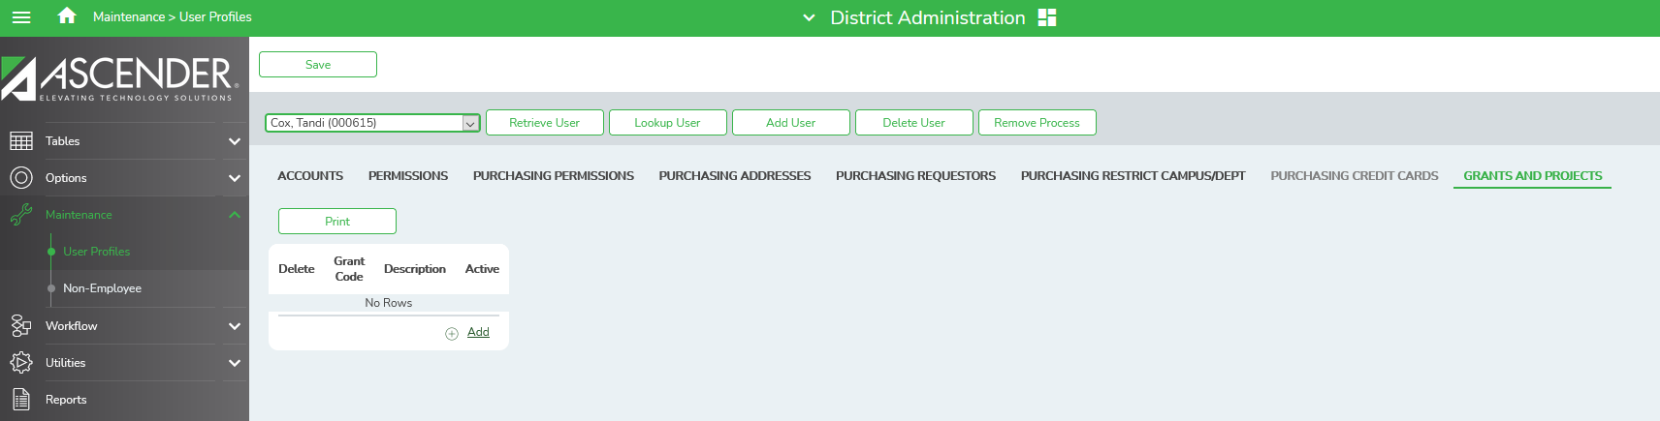
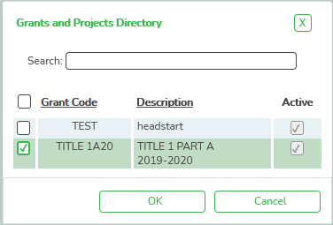
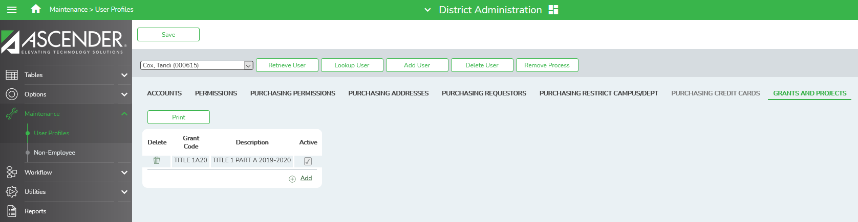

GL Inquiry

Grants and Projects > Inquiry > GL Inquiry
This page is used to perform inquiries for specific grant/project codes for the entire grant period regardless of the File ID.

To Perform a GL Inquiry:
Retrieval Options – If desired, select any of the following fields to exclude from the Inquiry:
Exclusions
  - Exclude Objects 61XX – Select to exclude all object codes related to payroll.
  - Exclude Accounts with No Transactions – Select to exclude all accounts that do not have associated transactions.
Description
- Reason – Select to display the reason for each account transaction
- Vendor Name – Select to display the vendor name for each account transaction.

Grant/Project Code:
- Type grant/project code, or click the ellipses to perform a search in the Grants and Projects Code Directory and select a code from the list.

Account Code:
- Narrow your search by entering an account code in each of the account code components. Account components that remain masked (Xs) will pull any digit in that position in the account code.
- For example, the account mask XXX-XX-63XX-XX-XXX-XXXXXX would pull all grant expenditure amounts for supplies.
- Retrieve

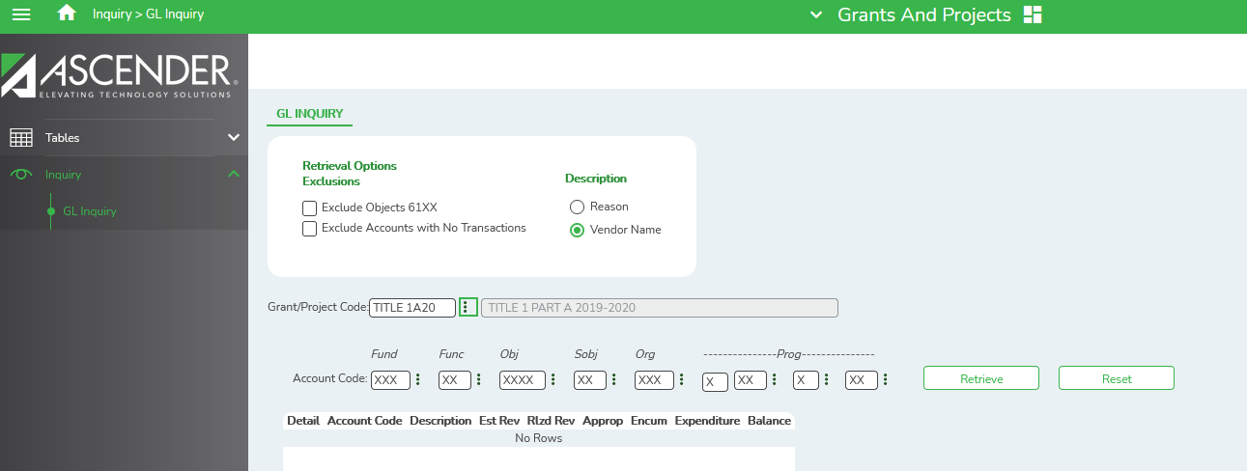

Seeing the totals for the grant:

Example of General Ledger Inquiries from Finance File IDs 0 and C, then a GL Inquiry from Grants and Projects to show the combined totals:

Finance > File ID 0 > Inquiry > General Ledger Inquiry > General Ledger Account Summary tab > 211/0

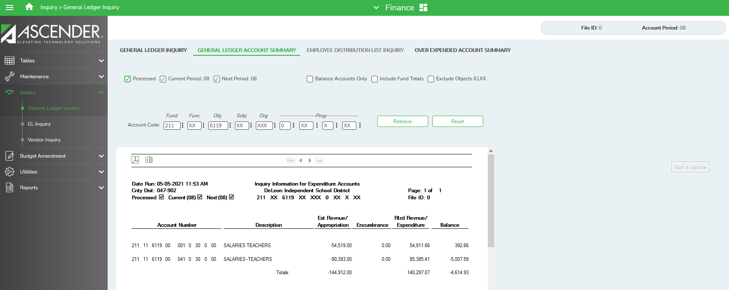

Finance > File ID C > Inquiry > General Ledger Inquiry > General Ledger Account Summary tab > 211/0

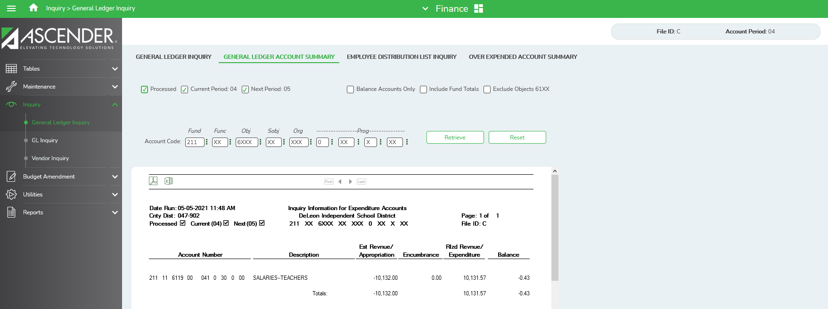

Grants and Projects > Inquiry > GL Inquiry

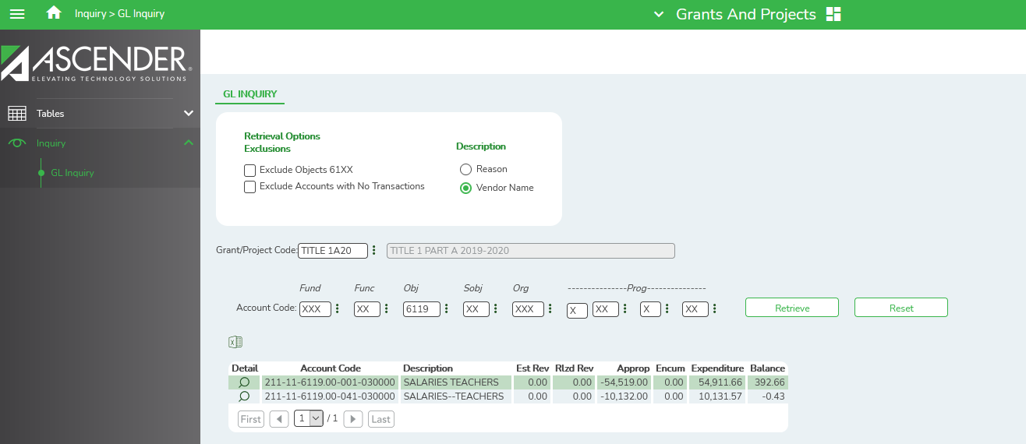
NOTE: THIS SCREENSHOT WILL HAVE TO BE UPDATED WHEN TCC CORRECTS ISSUE. ONLY HERE FOR PLACEHOLDER

Drill-Down Feature:
Selecting the spyglass on an account will display the transaction details for that account.
From the transaction details pop-up window, click a Transaction number to display another pop-up window with a list of the related transactions. The transaction type determines the displayed view.

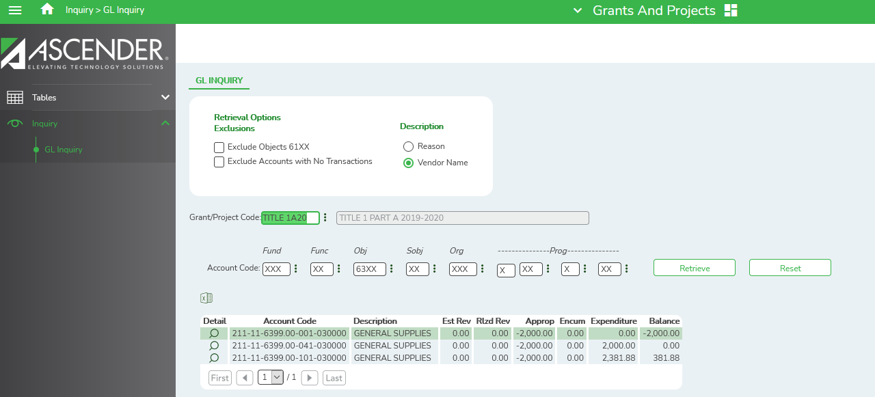

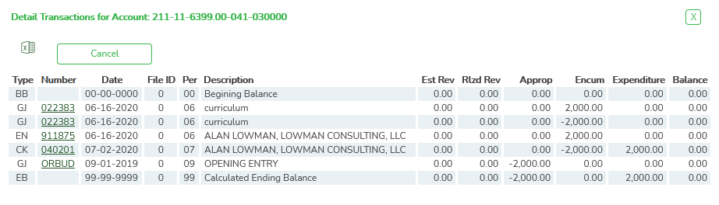
You can click various transaction numbers and the pop-up window is refreshed with the newly selected transaction data. This prevents user from having to close the pop-up window each time you click a different transactions number.

Example of an encumbrance (EN):

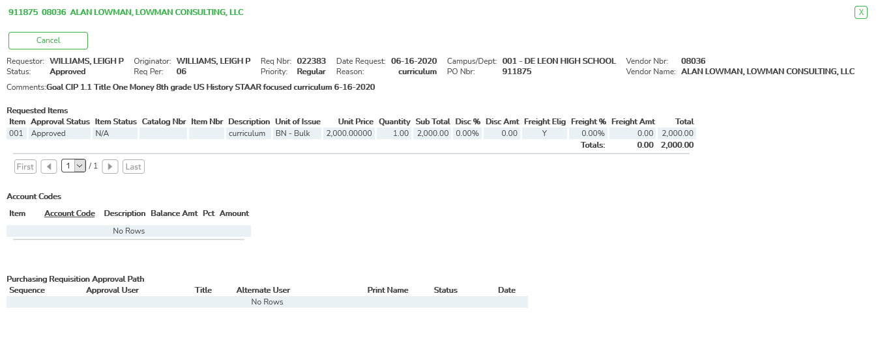

Example of a general journal (GJ):

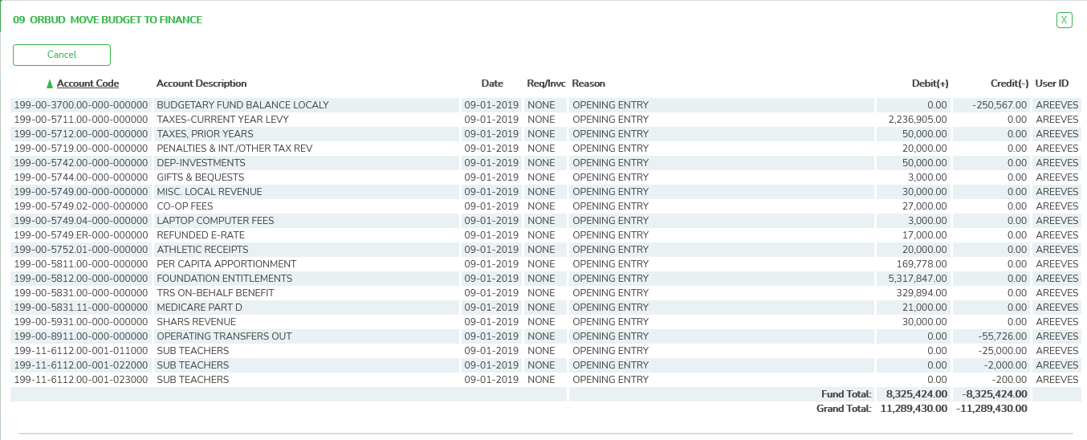

Example of a check (CK):

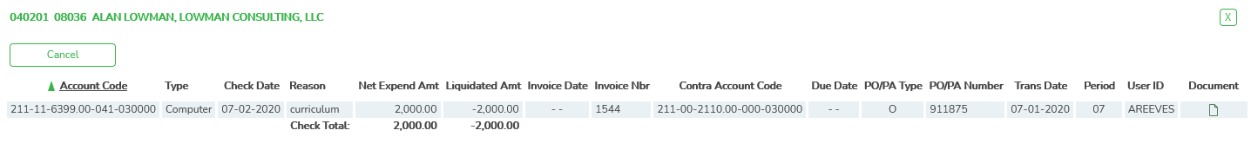
Notes on Audit Entries for funds continued during the EOY Fiscal Year close.

If an audit entry needs to be entered for a continuing fund, the account(s) may need to be activated at Finance > Maintenance > Create Chart of Accounts in the prior year File ID.

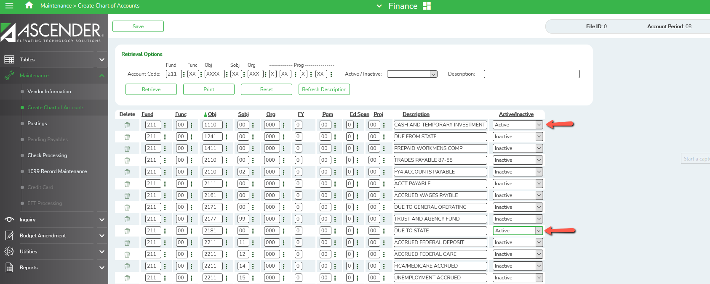

Finance > Maintenance > Postings > Journal Actual or Journal Budget

When entering an Audit Entry in Journal Actual or Journal Budget in Finance, if the entry is in two File ID’s, the Grants and Projects will show both entries. To prevent this, check the Ignore for Grants and Projects in Current but not in the previous file ID. This will prevent it from listing the same amount twice by not showing in both file ids’ in Grants and Projects but will still show both in the GL in Finance.

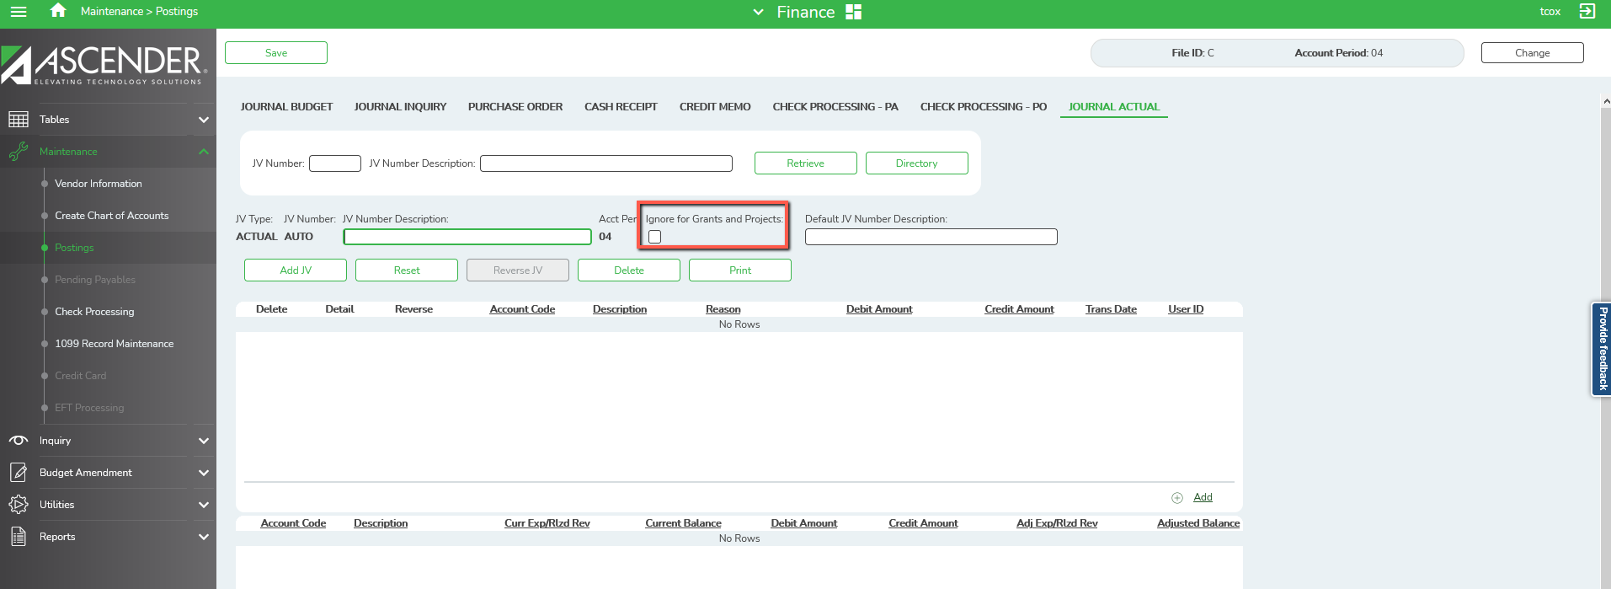

Note 1: The ‘Ignore for Grants and Projects’ is only shown on the Journal Actual and Journal Budget.

Note 2: The accounts and account masks defined on the Grants and Projects record in the Grants and Projects table are used to determine which accounts are selected for the initial display. Once the accounts are displayed, and detailed view may include accounts that are not included in the grant definition list of eligible accounts. For example: If the grant definition includes fund 211 and you drill down to a check record that includes funds 199, 202 and 211, you will see all of the transactions included in the check (all of the funds of 199, 202 and 211). Finance User profile settings are currently used for the detail pop-ups.

Note 3: Details Pop-up Tip: The totals only display the amounts for the accounts to which you have access. It is possible that the amounts may appear out-of-balance because you do not have access to a specific account(s). For example, if you have access to one account on a PO, you can view all of the purchase order details except the accounts to which you do not have access and the items that are fully paid out of an account to which you do not have access.

Note 4: The GJ for Opening Entries that was created to carry forward continuing funds in File ID C during the EOY process will not show in Grants and Projects. For continuity throughout the fiscal years, File ID C needs to have an opening entry that is equal to the ending balance; however, when viewed across all File IDs, the opening entry from one year to the next will not display so as to not double the total when you create this from Grants and Projects in a CSV/Excel report.

